We start our Association rule discovery on the bank data by first exploring our data and performing exhaustive data wrangling which includes data cleaning, data integrity checks, missing imputations and converting variables such that they suit our Association rule mining function.

**Pre-Processing Data**

1.Loading the csv file:

library(plyr)

library(dplyr)

library(arules)

bd=read.csv('C://Users//Harsh Darji//Downloads//bankdata_csv_all.csv')

2. Structure of the data

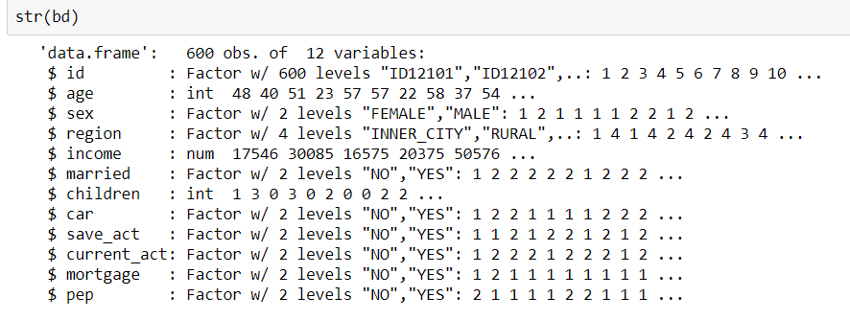

We observe that, age and income variables are not in a factor form. Also, they are continuous variables which makes them difficult to associate with other parameters. So, we perform discretization that is convert these continuous variables to discrete variables by grouping them into bins.

3. Discretization



Here, we clubbed all ages with age from 1-10 as child, 10-20 as teens and so on.

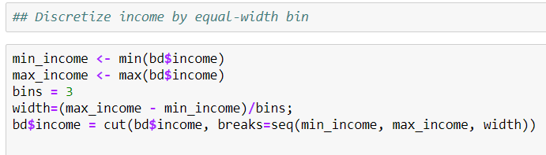

Similarly, for income variable we created 3 bins using the formula mentioned above.

4. Convert numeric attributes to Nominal

Now, we convert numerical attributes to Nominal variable.

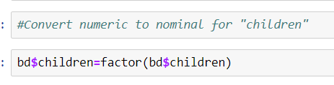

5. Conversion

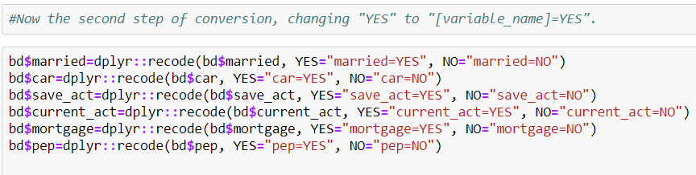

6. Dropping ID column

We drop ID column as it is not significant for our Association rule mining.

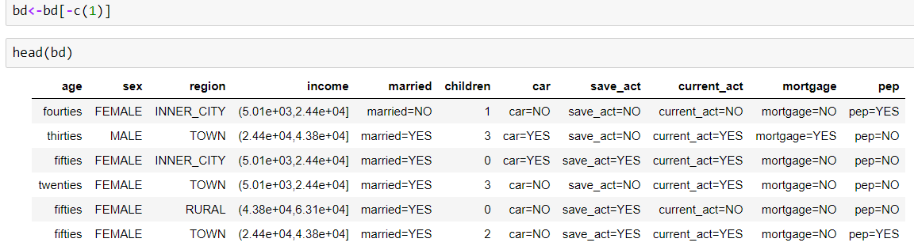

**Applying Apriori Algorithm**

Applying Apriori Algorithm, we set support to 0.25 and confidence to 0.7 and we get set of rules. When we set support to 0.30 and conf to 0.8 we don’t get enough rules so, we stick to below mentioned parameters.

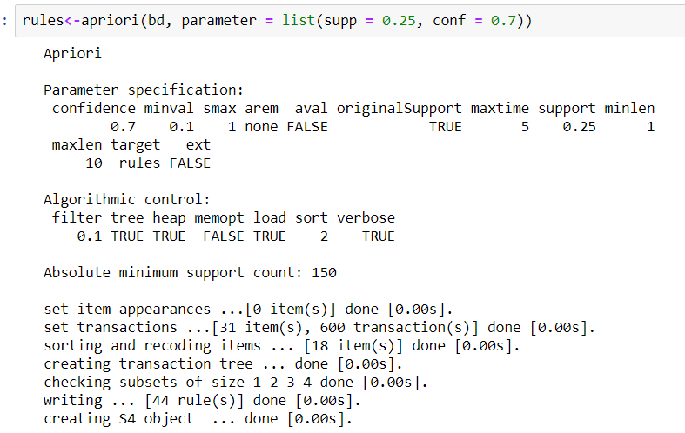

Summarizing

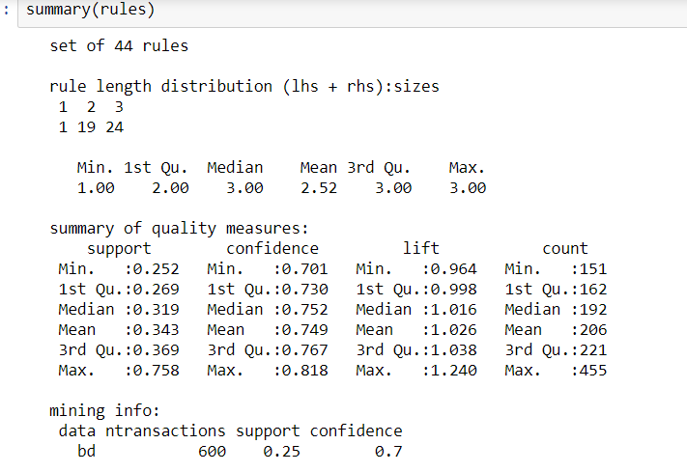

Displaying Association Rules

Top 10 rules with lift count in decreasing order. Max lift of 1.24 is observed also min lift is 1.05.

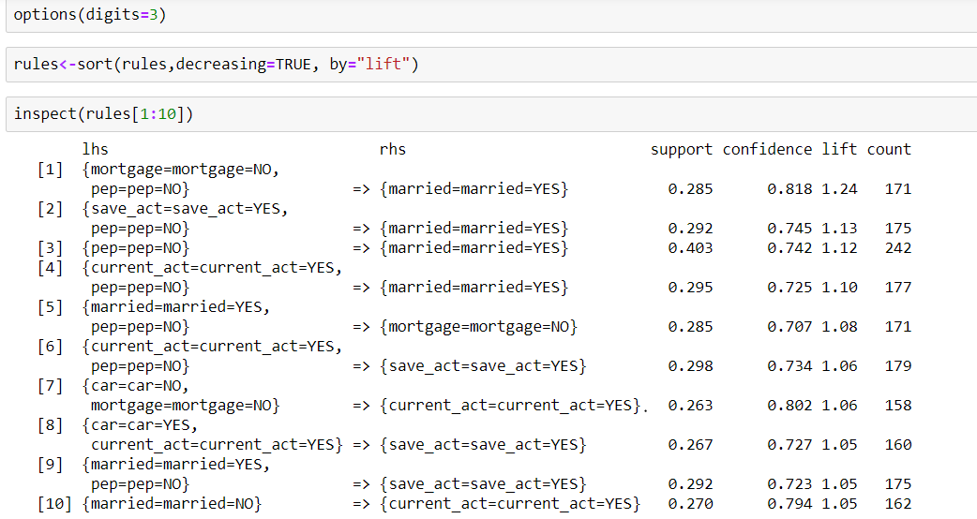

**Interesting Observation**

We observe that person with NO mortgage and NO personal equity plans (PEP) is more likely to be married. Also, if person has a saving account and NO personal equity plans (PEP) then he is likely to be married.

Plotting Rules

>>plot(rules[1:10],method="graph")

A close up of a map

Description generated with high confidence

**PEP Analysis**

Now, we analyze PEP considering other parameters of a person.

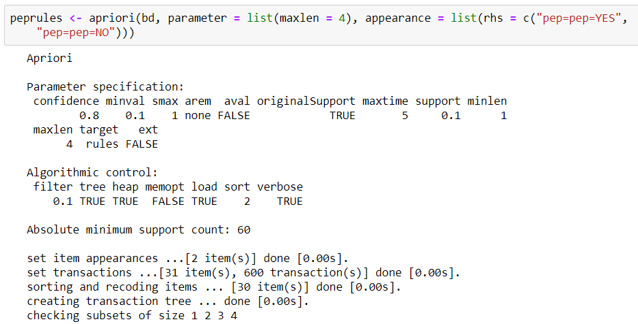

**PEP Rules**

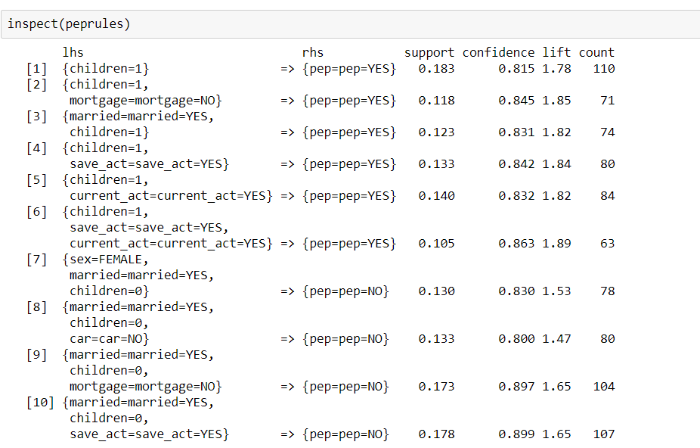

**Plotting PEP rules**

>>plot(myrules[1:10], method = "graph")

A close up of a map

Description generated with high confidence

**Plotting rules were PEP=NO**

>>plot(myrules[7:10], method = "graph")

**A screenshot of a cell phone

Description generated with high confidence**

**Interesting Observation**

When we observe rule 7 through 10, where Personal Equity Plan (PEP), we see that person with NO children has NO PEP even if they are married. So, client should not target customers with NO children or rather focus more on people with children. We also observe that people with NO PEP, NO children means less expenses thus NO mortgage.

**PEP rules sorted by Lift**

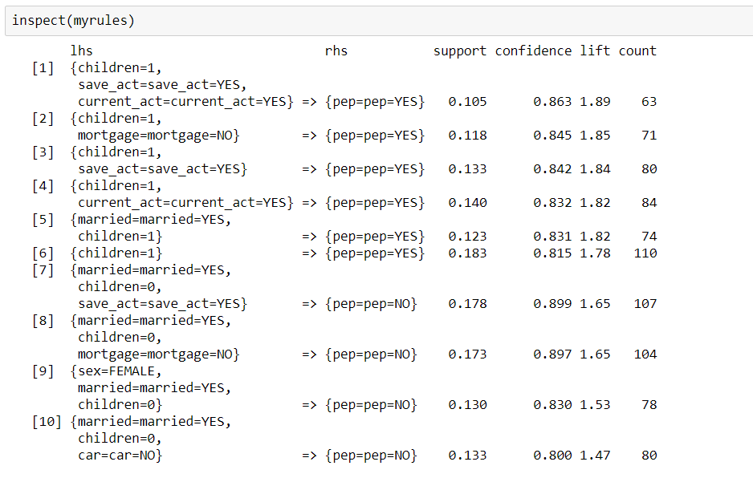

**Plotting rules were PEP=YES**

>>plot(myrules[1:6], method = "graph")

**A close up of a map

Description generated with high confidence**

**Interesting Observation**

We observe that when a people have children, they have PEP. Also, they have a savings as well as current account which suggests that people with children have a future planning and are potential customers to buy PEP. Also, they have a support of 1.05, confidence of 0.863 and max lift of 1.89 which indicates that PEP is dependent on number of children, savings account and current a

Plotting rules with PEP=YES